Telecom Customer Intelligence
& Churn Prediction
Executive Project Report | EDA • BI Dashboard • Predictive Modeling
14.7%  Overall churn | 43.6%  International-plan churn | 98.1%  Model accuracy | 98.6%  ROC-AUC | 92.7%  Model F1

1. Outlook
Objective. Turn a customer-level telecom dataset into an actionable churn-intelligence workflow: identify churn patterns, communicate them through a Power BI dashboard, and predict customers at elevated churn risk using an optimized XGBoost gradient-boosted tree ensemble.
Manager value. The project connects descriptive analytics to predictive decision support. The output can help prioritize retention analysis, customer-service interventions, and targeted offers rather than treating all customers equally.

2. Overview & Introduction
The project analyzes 2,666 customer records with 20 features covering account characteristics, subscription plans, voice/data usage proxies, charges, international activity, and customer-service interactions. The workflow follows a practical analytics lifecycle: data validation → exploratory data analysis → business-oriented segmentation → Power BI visualization → churn classification → evaluation and interpretation.

3. Problem Definition
Customer churn is a business-risk problem because retention decisions require identifying which customer profiles are more likely to leave. The analytical problem was therefore defined as a binary classification task: predict whether a customer will churn (True/False), while using EDA and BI to explain the strongest observable patterns behind churn. Because the dataset is a static snapshot, the findings should be interpreted as associations, not causal effects or a measured time-to-churn forecast.

4. Key EDA Findings
• Overall churn rate is 14.7%, meaning churn is a minority class and the retention population is substantially larger.
• International-plan customers show a 43.6% churn rate versus 11.2% for customers without the plan—one of the clearest segmentation signals in the analysis.
• Churned customers average about 205.2 day-time minutes versus 175.1 for retained customers, indicating materially higher daytime usage among churners.
• Voice-mail-plan adoption is lower among churners: approximately 8.9% versus 16.7% among retained customers.
• Customer-service interaction is strongly associated with churn at higher call counts: churn reaches about 48.1% at 4 service calls and 40.8% at 5 calls. Very high call-count categories have small samples and should not be overinterpreted.
• International usage is only modestly different between churn groups, so international minutes alone are a weaker signal than the international-plan segment.
• Corresponding charge variables closely track their usage-minute variables; they provide limited independent information and should be interpreted with awareness of redundancy/multicollinearity.

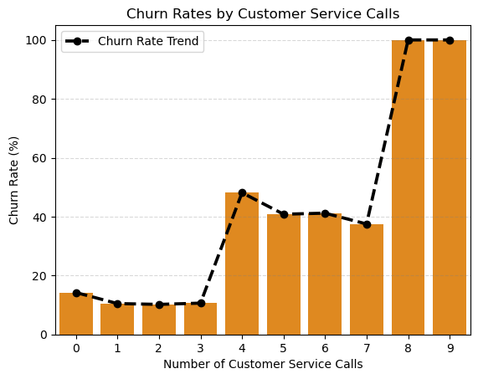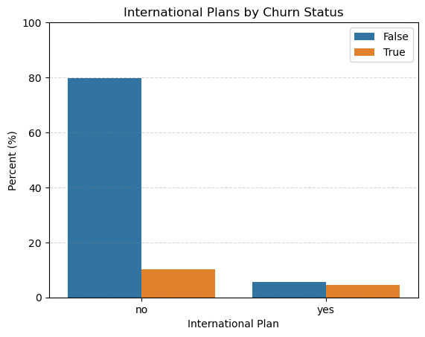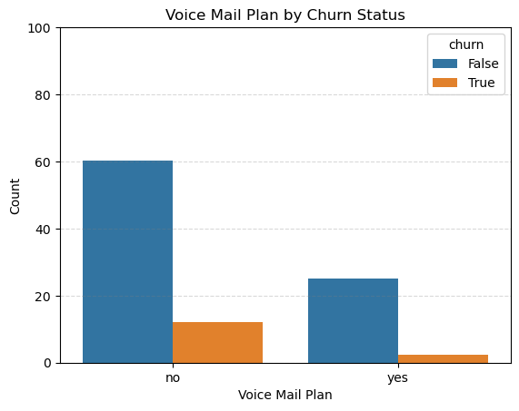
Figure 1.1 – Customer Churn by Different Parameters.

5. Business Intelligence Dashboard
The Power BI dashboard translates the EDA into an executive monitoring layer. It provides a compact view of overall churn, segment comparisons, and behavioral/service patterns so that stakeholders can move from “how much churn?” to “which customer groups look different?”
Dashboard view | Decision question
Churn rate by international plan | Which subscription segment has disproportionate churn?
Churn rate by voice-mail plan | Does plan adoption distinguish retention patterns?
Churn rate by customer-service calls | Where does support interaction become a potential churn-risk signal?
Usage / customer profile views | Which usage and account characteristics differ between churn groups?

6. Predictive Modeling
A supervised binary classification model was trained to predict churn. The selected approach is XGBoost, a gradient-boosted decision-tree ensemble that builds trees sequentially to correct previous model errors. The model was optimized for the project and evaluated on a held-out test set.
98.1%  Accuracy | 98.8%  Precision | 87.4%  Recall | 92.7%  F1-score | 98.6%  ROC-AUC

Interpretation. The 98.6% ROC-AUC indicates strong ranking/discrimination capability on the test set. Precision of 98.8% means predicted churners were highly reliable, while recall of 87.4% indicates that the model captured most—but not all—actual churners. F1-score of 92.7% provides a useful balance between these two objectives. Accuracy is reported for completeness, but should not be the primary business metric given the imbalanced churn distribution.

7. End-to-End Workflow
DATA → EDA → BUSINESS QUESTIONS → POWER BI → FEATURE ENGINEERING → XGBOOST → TEST EVALUATION → ACTIONABLE RISK SIGNALS

8. Future Work
• Add time-based customer history to move from static churn classification toward early-warning churn prediction and a defined prediction horizon.
• Use probability calibration and a business-selected decision threshold instead of relying only on the default classification threshold.
• Evaluate PR-AUC, confusion matrix, lift/gain and cost-sensitive metrics to quantify the operational value of contacting predicted churners.
• Apply model explainability (e.g., SHAP) to identify the strongest customer-level drivers and make model outputs easier for business teams to act on.
• Validate the model on a temporally newer or external dataset to test robustness and reduce the risk of overestimating offline performance.
• Connect dashboard segments to retention actions and measure intervention outcomes, creating a closed-loop churn-management process.

9. Executive Conclusion
This project demonstrates an end-to-end customer analytics capability: it identifies meaningful churn segments through EDA, turns those findings into a decision-oriented Power BI dashboard, and builds a high-performing XGBoost classifier for customer-risk prediction. The strongest observable signals include international-plan membership, higher daytime usage, voice-mail-plan adoption, and repeated customer-service interactions. The next maturity step is not simply a more complex model; it is operational validation, explainability, threshold optimization, and linking predictions to measurable retention actions.
Method note: Percentages are rounded. EDA relationships are associative; they do not establish causation. Test metrics reflect the stated held-out test set.

